Take-Home Assignment: Advanced Drone Delivery Navigation
Case Study:
A logistics company uses autonomous drones to deliver packages across a city. The city is represented as a graph where intersections are nodes and roads are edges. Each road has a travel time in minutes.
Constraints:
- Drones have limited battery life (max distance per trip).
- Some roads may have traffic delays.
- The goal is to find the shortest-time path from a warehouse to a customer.
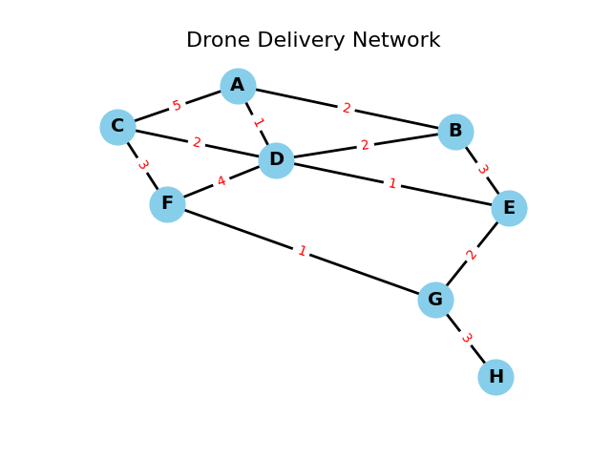

Part 1: Conceptual Questions (Theory)
- Depth-Limited Search
  - Explain how depth-limited search can be applied to this drone problem.
  - What are the potential drawbacks of using a fixed depth limit in a large network?
- Iterative Deepening Search
  - How does iterative deepening overcome the drawbacks of depth-limited search?
  - Discuss pros and cons in a dynamic city network.
- BFS and DFS
  - Explain how Breadth-First Search (BFS) and Depth-First Search (DFS) would explore the city graph.
  - Which one is better for shortest path discovery in an unweighted graph? Why?
- Uniform Cost Search (UCS)
  - Describe how UCS guarantees the shortest path when edge costs differ.
  - Identify drawbacks if the graph is very large.
- A Search*
  - Propose an admissible heuristic (e.g., straight-line distance to goal).
  - Explain why a good heuristic reduces the number of nodes expanded.
- Bidirectional Search
  - Explain how bidirectional search can reduce search time.
  - Discuss potential challenges with dynamic traffic delays.

Part 2: Practical Implementation (Coding Task)
Objective: Implement BFS, DFS, UCS, and A* for a more complex city network.
Graph:
graph = {
'A': {'B': 2, 'C': 5, 'D': 1},
'B': {'A': 2, 'D': 2, 'E': 3},
'C': {'A': 5, 'D': 2, 'F': 3},
'D': {'A': 1, 'B': 2, 'C': 2, 'E': 1, 'F': 4},
'E': {'B': 3, 'D': 1, 'G': 2},
'F': {'C': 3, 'D': 4, 'G': 1},
'G': {'E': 2, 'F': 1, 'H': 3},
'H': {'G': 3}
}

heuristic = {
'A': 7,
'B': 6,
'C': 6,
'D': 4,
'E': 2,
'F': 2,
'G': 1,
'H': 0
}

start = 'A'
goal = 'H'
Tasks:
- Implement DFS (no costs) to find a path from A → H.
- Implement BFS (no costs) to find the shortest path in terms of number of steps.
- Implement UCS to find the shortest path considering edge costs.
- Implement A* using the heuristic provided.
- Compare:
  - Paths found by DFS, BFS, UCS, and A*.
  - Number of nodes expanded by each algorithm.
- Optional: Add battery constraints (max travel cost) and update algorithms to handle this.
______________________________________________________________________________
Note Deliverables
- Written answers for Part 1.
- Python code for BFS, DFS, UCS, and A*.
- Output of:
  - Path found by each algorithm.
  - Total cost (for UCS/A*) or number of steps (BFS/DFS).
  - Number of nodes expanded.
- Optional: Demonstrate pathfinding with battery constraints.

